# Connect webcam to live stream:

<https://github.com/DeTeam/webcam-stream/blob/master/Tutorial.md>

## Linux integrated Camera

1. Sudo apt install ffmpeg
2. Create a script file named webcam.sh.

ffmpeg -i /dev/video0 -c:v h264 -c:a copy -b:v 150k -f flv rtmp:127.0.0.1/live/stream

#!/bin/bash

ffmpeg -loglevel warning -re -i /dev/video0 -c:v h264 -c:a copy -b:v 64k -preset veryfast -g 30 -r 30 -f flv -flvflags no_duration_filesize "rtmp:127.0.0.1/live/stream"

1. make it executable (chmod +x webcam.sh)
2. Sudo bash webcam.sh

On Window 10 using Open Broadcast Software (OBS) studio

1. Install OBS Studio
2. Set up the settings to steam to rtmp://192.168.0.14:1935/live2/stream2

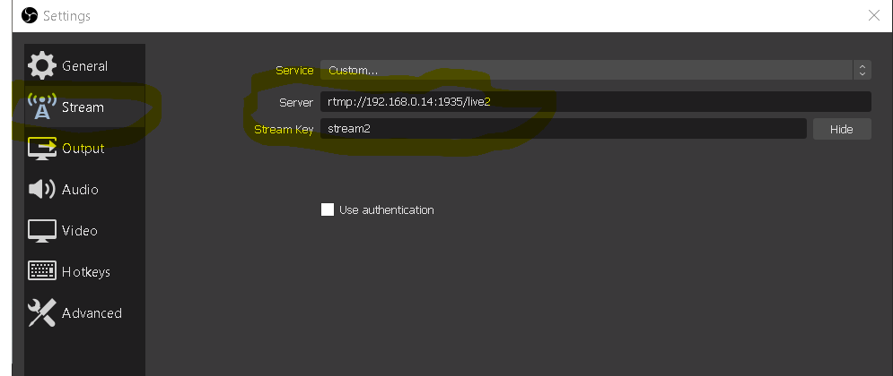

**/var/www/winn-live/Index.html –**

browsing http://192.168.0.14:81/ will bring this player up

<html>

<head>

<title>Winn Live Stream</title>

<meta charset="utf-8" />

<!-- CSS -->

<link href="https://vjs.zencdn.net/7.2.3/video-js.css" rel="stylesheet">

</head>

<body>

<h3>Winn Live Strem #1 (videojs)</h3>

<video id='winn-live1' class="video-js vjs-default-skin" width="400" height="300" controls>

<source type="application/x-mpegURL" src="/hls/stream.m3u8">

</video>

<!--

<a href="index2.html">Watch Live #2</a>

-->

<h3>Winn Live Strem #2 (videojs)</h3>

<video id='winn-live2' class="video-js vjs-default-skin" width="400" height="300" controls>

<source type="application/x-mpegURL" src="/hls2/stream2.m3u8">

</video>

<!-- JS code -->

<!-- If you'd like to support IE8 (for Video.js versions prior to v7) -->

<script src="https://vjs.zencdn.net/ie8/ie8-version/videojs-ie8.min.js"></script>

<script src="https://cdnjs.cloudflare.com/ajax/libs/videojs-contrib-hls/5.14.1/videojs-contrib-hls.js"></script>

<script src="https://vjs.zencdn.net/7.2.3/video.js"></script>

<script>

var player1 = videojs('winn-live1');

player1.play();

var player2 = videojs('winn-live2');

player2.play();

</script>

</body>

</html>

<!DOCTYPE html>

<html>

<head>

<title>Winn Live Stream</title>

<meta charset="utf-8" />

<script type="text/javascript" src="https://cdn.jsdelivr.net/npm/clappr@latest/dist/clappr.min.js"></script>

</head>

<body>

<H3>Winn Live Stream</H3>

<div id="player">

</div>

<script>

var player = new Clappr.Player({

source: "/hls/stream.m3u8",

parentId: "#player",

maxBufferLength: 10,

width: 640,

height: 360

});

</script>

</body>

</html>